**Experiment – 12**

**Aim: Introduction To NODE MCU esp8266 and Raspberry pi.**

* **Introduction to NodeMCU ESP8266**

Arduino is an Italian open-source hardware and software company, project, and user community that designs and manufactures single-board microcontrollers and microcontroller kits for building digital devices. Its hardware products are licensed under a CC BY-SA license, while the software is licensed under the GNU Lesser General Public License (LGPL) or the GNU General Public License (GPL), permitting the manufacture of Arduino boards and software distribution by anyone. Arduino boards are available commercially from the official website or through authorized distributors.

* **Types of Board**

|  |  |  |  |
| --- | --- | --- | --- |
| Type | Board Name | Year | Price (INR) (Approx.) |
| Wi-Fi Enabled | NodeMCU ESP8266 | 2014 | ₹250 – ₹400 |
| Compact + Wi-Fi | ESP-01 | 2014 | ₹150 – ₹250 |
| Advanced IoT | ESP32 Dev Module | 2016 | ₹300 – ₹500 |
| Low Power | Wemos D1 Mini | 2015 | ₹200 – ₹300 |
| Sensor Focused | NodeMCU ESP8266 + DHT | 2015 | ₹350 – ₹500 |

|  |  |
| --- | --- |
| **Component** | **Description** |
| Microcontroller | ESP8266 (Tensilica Xtensa 32-bit LX106) |
| Operating Voltage | 3.3V |
| Input Voltage (via USB) | 5V (regulated to 3.3V internally) |
| Digital I/O Pins | 11 GPIO (some with dual functions) |
| Analog Input Pins | 1 (ADC0, 10-bit resolution) |
| Flash Memory | 4 MB (varies by board) |
| Clock Speed | 80 MHz (can be overclocked to 160 MHz) |
| Communication | UART, SPI, I2C |
| USB Interface | Micro USB for programming and power |
| Wi-Fi | 802.11 b/g/n 2.4GHz Wi-Fi built-in |
| Dimensions | Approx. 58 mm × 31 mm |
| Programming Support | Arduino IDE, Lua, MicroPython |
| Power Connector | Barrel Jack and Vin Pin |
| LED Indicators | Power (ON), TX/RX, and Pin 13 LED |
| Reset Button | Yes |
| Board Dimensions | 68.6 mm × 53.4 mm |

* **Components of NodeMCU ESP8266**
* 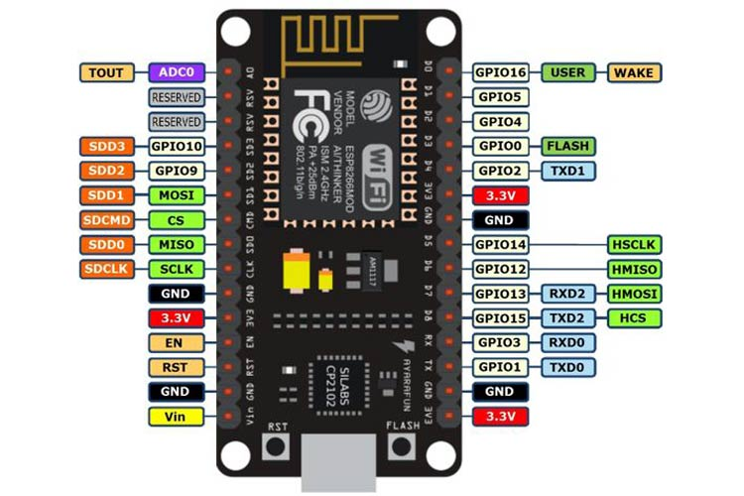**Pin diagram of NodeMCU ESP8266**
* **Introduction to Raspberry Pi**

Raspberry Pi is a small, powerful, and affordable single-board computer developed by the Raspberry Pi Foundation to promote computer science education and DIY innovation. It supports a full operating system (typically Raspberry Pi OS, based on Linux) and offers all essential features of a desktop PC, including USB ports, HDMI output, audio, Ethernet, and wireless connectivity (in newer models). Raspberry Pi can run programming languages like Python, Java, and C++, and is commonly used in automation, robotics, media centers, home servers, and IoT applications. Its GPIO (General Purpose Input Output) pins allow it to interface with sensors, motors, and external devices, making it a flexible platform for hardware and software development.

* **Types of Board**

|  |  |  |  |
| --- | --- | --- | --- |
| **Type** | **Board Name** | **Year** | **Price (INR) (Approx.)** |
| Entry-Level | Raspberry Pi Zero W | 2017 | ₹1,000 – ₹1,200 |
| General Purpose | Raspberry Pi 3 Model B+ | 2018 | ₹3,000 – ₹4,000 |
| Advanced | Raspberry Pi 4 Model B | 2019 | ₹4,000 – ₹8,000 |
| High Performance | Raspberry Pi 5 | 2023 | ₹6,000 – ₹10,000+ |
| Compact + Basic | Raspberry Pi Pico | 2021 | ₹300 – ₹500 |
| Industrial/CM | Compute Module 4 | 2020 | ₹3,500 – ₹7,000 |

* **Components of Raspberry Pi 4 Model B**

|  |  |
| --- | --- |
| **Component** | **Description** |
| CPU | Quad-core Cortex-A72 (64-bit) @ 1.5 GHz |
| RAM Options | 2GB, 4GB, 8GB LPDDR4 |
| GPU | Broadcom VideoCore VI |
| Operating System | Raspberry Pi OS (Linux-based), also supports Ubuntu, Windows IoT |
| GPIO Pins | 40-pin GPIO header with I2C, SPI, UART, PWM support |
| USB Ports | 2 × USB 2.0, 2 × USB 3.0 |
| Video Output | 2 × micro-HDMI (up to 4K output) |
| Audio | HDMI and 3.5 mm audio jack |
| Storage | microSD card slot for OS and file storage |
| Connectivity | Wi-Fi 802.11ac, Bluetooth 5.0, Gigabit Ethernet |
| Power Supply | 5V/3A via USB-C port |
| Camera Support | CSI Camera port for Raspberry Pi Camera Module |
| Display Support | DSI Display port for touchscreens |
| Dimensions | 85.6 mm × 56.5 mm |

* 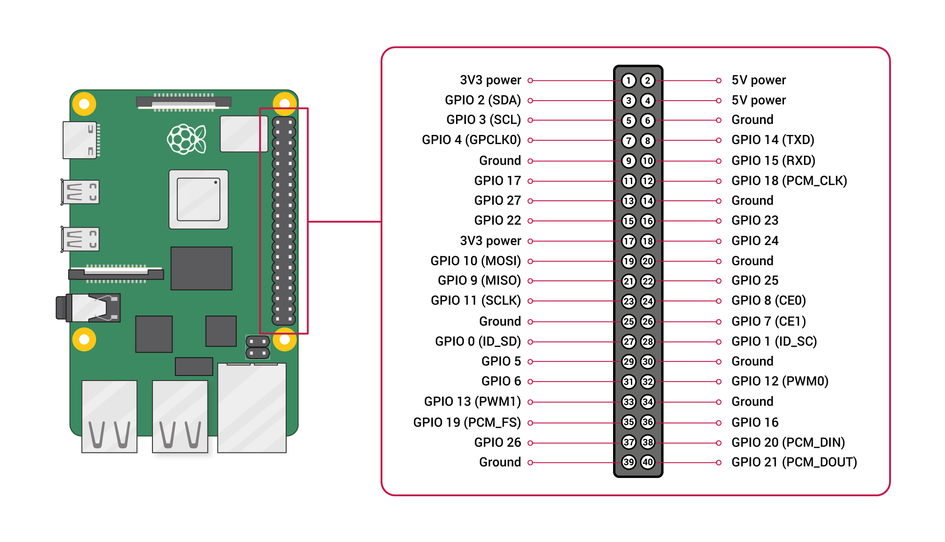**Pin Diagram of Raspberry Pi GPIO (40-pin header)**
* **Application and use – cases**

**5. Applications and Use-Cases**

* Home Automation: Control lights, fans, door locks, and other appliances using smart interfaces.
* IoT Projects: Collect sensor data and upload to cloud platforms like AWS, Azure, or ThingsBoard.
* Media Center: Run Kodi or Plex to turn Raspberry Pi into a home media server.
* Web Server: Host your own website or web-based application on Apache/Nginx server.
* Robotics: Interface with sensors, motors, and cameras to build autonomous robots.
* Educational Tool: Learn Linux commands, programming, electronics, and networking.
* Security & Surveillance: Use Pi with a camera module for CCTV or motion detection systems.
* AI & ML: Run lightweight models for image processing or voice recognition.